EC-467 Mobile Application Development

BS (CE)-2021 LAB REPORT #10
Submitted By:

Reg. No. | Name
21-CE-009 | Huzaifa Shahbaz

Department of Computer Engineering
HITEC University Taxila
 | Presentation  (Format(0.5)+  Title (0.5)+  Conclusion(1)  +Procedure(2)  +Objective(1)) | Calculation/ Coding | Observation/  Program Results | Total
Total | 5 | 5 | 5 | 15
Obtained

Lab Instructor.
Dr. Muhammad Bilal

LAB REPORT #10
SQLite Database
Introduction: Structure Query Language (SQL) is a database query language used for storing and managing data in Relational Database Management System (DBMS). The APIs you'll need to use a database on Android are available in the “android.database.sqlite”Adapter” Contract Class in SQLite: A contract class is a container for constants that define names for tables, and columns. The contract class allows you to use the same constants across all the other classes in the same package. This lets you change a column name in one place and have it propagate throughout your code. A good way to organize a contract class is to put definitions that are global to your whole database in the root level of the class. SQLite Helper Class: Once you have defined how your database looks, you should implement methods that create and maintain the database and tablesusing the “SQLiteOpenHelper” class. The “SQLiteOpenHelper” class contains a useful set of APIs for managing your database. The database can be manage by calling “getWritableDatabase()” or “getReadableDatabase()” callbacks in helper class. When you extends your helper class with “SQLiteOpenHelper” two callbacks must be implemented i.onCreate() ii.onUpgrade()
“ContentValues” for Entiresin SQLite: ContentValuesis a maplikeclass that matches a value to a String key. It contains multiple overloaded put methods that enforce type safety. Here is a list of the put methods supported byContentValues i.void put(String key, String value) ii.void put(String key, Integer value) iii.String getString(String Key) iv.Integer getInt(String Key) v.Integer getColumnIndex(String ColumnName) Read All Entries from SQLite Table: The SQL query can be implement to read all entries from table by executing the “rawQuery()”method, which will return the “Cursor”. Cursorsare what contain the result set of a query made against adatabaseinAndroid. TheCursorclass has an API that allows an app to read (in a type-safe manner) the columns that were returned from the query as well as iterate over the rows of the result set.
Tools: Android Studio Jellyfish
Objectives of the experiment: 1. To get basic understanding regarding SQLite 2.To get basic understanding regarding how SQLite use to design database in android studio 3.To get to know about the benefits related to SQLite
Class Task JAVA CODE OF Main Activity: package com.huzaifashahbaz.sqllitedatabaseapp;
import android.os.Bundle;
import android.view.View;
import android.widget.ArrayAdapter;
import android.widget.EditText;
import android.widget.ListView;
import android.widget.Toast;
import androidx.appcompat.app.AppCompatActivity;
public class MainActivity extends AppCompatActivity {
EditText idET,nameET,addressET;
SchoolDBHelper dbHelper;
ListView listView;
SchoolBaseAdapter adapter;
@Override
protected void onCreate(Bundle savedInstanceState) {
super.onCreate(savedInstanceState);
setContentView(R.layout.activity_main);
idET=findViewById(R.id.id_et);
nameET=findViewById(R.id.name_et);
addressET=findViewById(R.id.add_et);
listView=findViewById(R.id.listview);
dbHelper=new schoolBaseAdpater(getApplicationContext(),schoolSetters);
listView.setAdapter(adapter);
}
public void addNewEntry(View view)
{
if (!idET.getText().toString().matches("")||!nameET.getText().toString().matches("") || !addressET.getText().toString().matches(""))
{
int id = Integer.valueOf(idET.getText().toString());
String name = nameET.getText().toString();
String address = addressET.getText().toString();
dbHelper.addEntry(id, name, address);
updateListView();
}
else
{
Toast.makeText(this, "Fill all edit box", Toast.LENGTH_SHORT).show();
}
}
void UpdateListView()
{
ArrayAdapter<SchoolContract>schoolSetters=dbHelper.readALL();
adapter=new SchoolBaseAdapter(getApplicationContext(),schoolSetters);
listView.setAdapter(adapter);
listView.invalidateViews();
}
}
XML CODE OF Main Activity:
<?xml version="1.0" encoding="utf-8"?>
<LinearLayout xmlns:android="http://schemas.android.com/apk/res/android"
xmlns:tools="http://schemas.android.com/tools"
xmlns:app="http://schemas.android.com/apk/res-auto"
android:padding="5dp"
android:layout_width="match_parent"
android:layout_height="match_parent"
android:orientation="vertical">
<LinearLayout
android:layout_width="match_parent"
android:layout_height="wrap_content"
android:orientation="horizontal">
<TextView
android:id="@+id/id_name"
android:layout_width="wrap_content"
android:layout_height="wrap_content"
android:layout_weight="1"
android:text="ID" />
<EditText
android:id="@+id/id_et"
android:layout_width="wrap_content"
android:layout_height="wrap_content"
android:layout_weight="1"
android:ems="10"
android:inputType="textPersonName"
android:hint="ID" />
</LinearLayout>
<LinearLayout
android:layout_width="match_parent"
android:layout_height="wrap_content"
android:orientation="horizontal">
<TextView
android:id="@+id/name_tc"
android:layout_width="wrap_content"
android:layout_height="wrap_content"
android:layout_weight="1"
android:text="Name" />
<EditText
android:id="@+id/name_et"
android:layout_width="wrap_content"
android:layout_height="wrap_content"
android:layout_weight="1"
android:ems="10"
android:inputType="textPersonName"
android:hint="Name" />
</LinearLayout>
<LinearLayout
android:layout_width="match_parent"
android:layout_height="wrap_content"
android:orientation="horizontal">
<TextView
android:id="@+id/add_tc"
android:layout_width="wrap_content"
android:layout_height="wrap_content"
android:layout_weight="1"
android:text="Address" />
<EditText
android:id="@+id/add_et"
android:layout_width="wrap_content"
android:layout_height="wrap_content"
android:layout_weight="1"
android:ems="10"
android:inputType="textPersonName"
android:hint="Address" />
</LinearLayout>
<LinearLayout
android:layout_width="match_parent"
android:layout_height="wrap_content"
android:orientation="horizontal">
<Button
android:id="@+id/add_btn"
android:layout_width="wrap_content"
android:layout_height="wrap_content"
android:layout_weight="1"
android:onClick="addNewEntry"
android:text="Add" />
</LinearLayout>
<ListView
android:id="@+id/list_view"
android:layout_width="match_parent"
android:layout_height="wrap_content" />
</LinearLayout>
JAVA CODE OF SCHOOLCONTRACT: package com.huzaifashahbaz.sqllitedatabaseapp;
public final class SchoolContract {
public static class Student {
public static final String TABLE_NAME = "student";
public static final String COLUMN_ID = "id";
public static final String COLUMN_NAME = "name";
public static final String COLUMN_ADDRESS = "address";
public static final String CREATE_STUDENT_TABLE =
"CREATE TABLE " + TABLE_NAME + "(" +
COLUMN_ID + " INTEGER PRIMARY KEY, " +
COLUMN_NAME + " TEXT, " +
COLUMN_ADDRESS + " TEXT) ";
public static final String DELETE_STUDENT_TABLE =
"DROP TABLE IF EXISTS " + TABLE_NAME;
public static final String READ_ALL_TABLE = "SELECT * FROM " +
TABLE_NAME;
}
}
JAVA CODE OF SCHOOlDBHELPER: package com.huzaifashahbaz.sqllitedatabaseapp;
import android.content.ContentValues;
import android.content.Context;
import android.database.Cursor;
import android.database.sqlite.SQLiteDatabase;
import android.database.sqlite.SQLiteOpenHelper;
import android.widget.Toast;
import androidx.annotation.Nullable;
import java.util.ArrayList;
public class SchoolDBHelper extends SQLiteOpenHelper {
Context context;
public static final int DATABASE_VERSION = 1;
public static final String DATABASE_NAME = "School.db";
public SchoolDBHelper(@Nullable Context context) {
super(context, DATABASE_NAME, null, DATABASE_VERSION);
this.context = context;
}
@Override
public void onCreate(SQLiteDatabase db) {
db.execSQL(SchoolContract.Student.CREATE_STUDENT_TABLE);
}
@Override
public void onUpgrade(SQLiteDatabase db, int oldVersion, int newVersion) {
db.execSQL(SchoolContract.Student.DELETE_STUDENT_TABLE);
onCreate(db);
}
public void addEntry(int id, String name, String address){
SQLiteDatabase db = getWritableDatabase();
ContentValues values = new ContentValues();
values.put(SchoolContract.Student.COLUMN_ID, id);
values.put(SchoolContract.Student.COLUMN_NAME, name);
values.put(SchoolContract.Student.COLUMN_ADDRESS, address);
try{
db. insertOrThrow (SchoolContract.Student.TABLE_NAME, null, values);
}catch (Exception e){
Toast.makeText(context, "Error: " + e, Toast.LENGTH_SHORT).show();
}
db.close();
}
public ArrayList<SchoolSetter> readAll(){
SQLiteDatabase db = getWritableDatabase();
Cursor cursor = db.rawQuery(SchoolContract.Student.READ_ALL_TABLE,null);
ArrayList<SchoolSetter> setters = new ArrayList<SchoolSetter>();
while (cursor.moveToNext()){
setters.add(new SchoolSetter(
cursor.getInt(0),
cursor.getString(1),
cursor.getString(2)
)
);
}
return setters;
}
}
JAVA CODE OF SCHOOLSETTER: package com.huzaifashahbaz.sqllitedatabaseapp;
public class SchoolSetter {
int id;
String name;
String address;
public SchoolSetter(int id,String name,String address)
{
this.id=id;
this.name=name;
this.address=address;
}
public int getId()
{
return id;
}
public String getName()
{
return name;
}
public String getAddress()
{
return address;
}
}
JAVA CODE OF SCHOOLBASEADAPTER: package com.huzaifashahbaz.sqllitedatabaseapp;
import android.content.Context;
import android.view.LayoutInflater;
import android.view.View;
import android.view.ViewGroup;
import android.widget.BaseAdapter;
import android.widget.TextView;
import java.util.ArrayList;
public class SchoolBaseAdapter extends BaseAdapter {
ArrayList<SchoolSetter> setter;
LayoutInflater inflater;
public SchoolBaseAdapter(Context context, ArrayList<SchoolSetter> setter) {
this.setter = setter;
inflater = LayoutInflater.from(context);
}
@Override
public int getCount() {
return setter.size();
}
@Override
public Object getItem(int position) {
return setter.get(position);
}
@Override
public long getItemId(int position) {
return position;
}
@Override
public View getView(int position, View convertView, ViewGroup parent) {
// get view of custom item layout
convertView = inflater.inflate(R.layout.list_item_sql, null);
TextView id = convertView.findViewById(R.id.item_id);
TextView name = convertView.findViewById(R.id.item_name);
TextView address = convertView.findViewById(R.id.item_address);
id.setText(String.valueOf(setter.get(position).getId()));
name.setText(String.valueOf(setter.get(position).getName()));
address.setText(String.valueOf(setter.get(position).getAddress()));
return convertView;
}
}

XML CODE OF SCHOOLBASEADAPTER: <?xml version="1.0" encoding="utf-8"?>
<LinearLayout xmlns:android="http://schemas.android.com/apk/res/android"
xmlns:app="http://schemas.android.com/apk/res-auto"
xmlns:tools="http://schemas.android.com/tools"
android:layout_width="match_parent"
android:layout_height="wrap_content"
android:orientation="vertical"
android:padding="16dp">
<TextView
android:id="@+id/item_id"
android:layout_width="wrap_content"
android:layout_height="wrap_content"
android:text="ID"
android:textSize="16sp"
android:textStyle="bold" />
<TextView
android:id="@+id/item_name"
android:layout_width="wrap_content"
android:layout_height="wrap_content"
android:text="Name"
android:textSize="16sp" />
<TextView
android:id="@+id/item_address"
android:layout_width="wrap_content"
android:layout_height="wrap_content"
android:text="Address"
android:textSize="16sp" />
</LinearLayout>
Results: 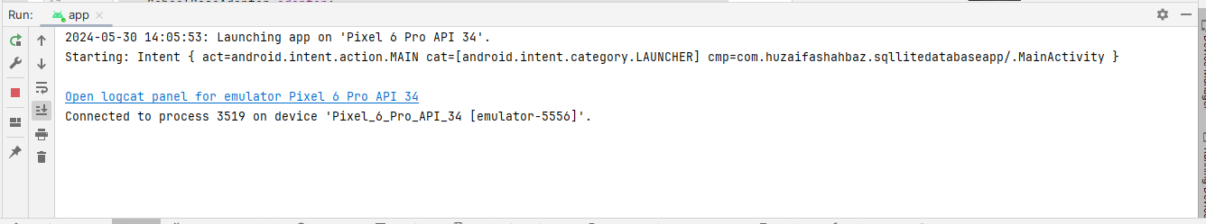
OUTPUT:
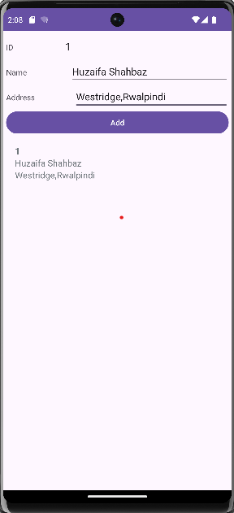
Home Task: Use Tasbeeh app and show history in view pager and store history in SQLite database. JAVA CODE OF Main Activity: package TasbeehSQLidatabase;
import android.annotation.SuppressLint;
import android.database.Cursor;
import android.os.Bundle;
import android.view.View;
import android.widget.Button;
import android.widget.TextView;
import android.widget.Toast;
import androidx.appcompat.app.AppCompatActivity;
import androidx.viewpager.widget.ViewPager;
import androidx.fragment.app.Fragment;
import androidx.fragment.app.FragmentManager;
import androidx.fragment.app.FragmentPagerAdapter;
import com.huzaifashahbaz.sqllitedatabaseapp.R;
public class MainActivity extends AppCompatActivity {
TextView tvCount;
Button btnCount, btnReset, btnViewHistory;
int Count = 0;
DatabaseHelper databaseHelper;
ViewPager viewPager;
HistoryPagerAdapter pagerAdapter;
@Override
protected void onCreate(Bundle savedInstanceState) {
super.onCreate(savedInstanceState);
setContentView(R.layout.activity_main);
tvCount = findViewById(R.id.text_view_count);
btnCount = findViewById(R.id.button_count);
btnReset = findViewById(R.id.button_reset);
btnViewHistory = findViewById(R.id.button_view_history);
viewPager = findViewById(R.id.view_pager);
databaseHelper = new DatabaseHelper(this);
pagerAdapter = new HistoryPagerAdapter(getSupportFragmentManager());
viewPager.setAdapter(pagerAdapter);
viewPager.setOffscreenPageLimit(1); // Cache one page on each side
}
public void onPressResetbtn(View view) {
Count = 0;
tvCount.setText("Count: " + Count);
}
public void onPressHistorybtn(View view) {
Toast.makeText(this, "JAZAKALLAH KHAIR", Toast.LENGTH_SHORT).show();
viewPager.setCurrentItem(0);
}
public void onPressCountbtn(View view) {
Count++;
tvCount.setText("Count: " + Count);
databaseHelper.insertCount(Count);
}
private class HistoryPagerAdapter extends FragmentPagerAdapter {
public HistoryPagerAdapter(FragmentManager fm) {
super(fm);
}
@Override
public Fragment getItem(int position) {
return new HistoryFragment();
}
@Override
public int getCount() {
return 1; // Number of tabs/pages
}
@Override
public CharSequence getPageTitle(int position) {
return "History";
}
}
}
XML CODE OF Main Activity: <?xml version="1.0" encoding="utf-8"?>
<LinearLayout xmlns:android="http://schemas.android.com/apk/res/android"
android:layout_width="match_parent"
android:layout_height="match_parent"
android:orientation="vertical"
android:padding="16dp">
<TextView
android:id="@+id/text_view_count"
android:layout_width="wrap_content"
android:layout_height="wrap_content"
android:text="Count: 0"
android:textSize="24sp"/>
<Button
android:id="@+id/button_count"
android:layout_width="wrap_content"
android:layout_height="wrap_content"
android:onClick="onPressCountbtn"
android:text="Count"/>
<Button
android:id="@+id/button_reset"
android:layout_width="wrap_content"
android:layout_height="wrap_content"
android:onClick="onPressResetbtn"
android:text="Reset"/>
<Button
android:id="@+id/button_view_history"
android:layout_width="wrap_content"
android:layout_height="wrap_content"
android:onClick="onPressHistorybtn"
android:text="View History"/>
<androidx.viewpager.widget.ViewPager
android:id="@+id/view_pager"
android:layout_width="match_parent"
android:layout_height="0dp"
android:layout_weight="1"/>
</LinearLayout>
JAVA CODE OF DATABASE HELPER:
package TasbeehSQLidatabase;
import android.content.ContentValues;
import android.content.Context;
import android.database.sqlite.SQLiteDatabase;
import android.database.sqlite.SQLiteOpenHelper;
public class DatabaseHelper extends SQLiteOpenHelper {
private static final String DATABASE_NAME="tasbeeh.db";
private static final int DATABASE_VERSION=1;
private static final String TABLE_NAME="history";
private static final String COLUMN_ID="id";
private static final String COLUMN_COUNT="count";
private static final String COLUMN_TIMESTAMP="timestamp";
public DatabaseHelper(Context context)
{
super(context,DATABASE_NAME,null,DATABASE_VERSION);
}
@Override
public void onCreate(SQLiteDatabase db)
{
String createTable = "CREATE TABLE " + TABLE_NAME + " (" +
COLUMN_ID + " INTEGER PRIMARY KEY AUTOINCREMENT, " +
COLUMN_COUNT + " INTEGER, " +
COLUMN_TIMESTAMP + " TIMESTAMP DEFAULT CURRENT_TIMESTAMP)";
db.execSQL(createTable);
}
@Override
public void onUpgrade(SQLiteDatabase db,int oldVersion,int newVersion)
{
db.execSQL("DROP TABLE IF EXISTS " + TABLE_NAME);
onCreate(db);
}
public boolean insertCount(int count)
{
SQLiteDatabase db=this.getWritableDatabase();
ContentValues contentValues=new ContentValues();
contentValues.put(COLUMN_COUNT,count);
long result= db.insert(TABLE_NAME,null,contentValues);
return result!=1;
}
}

JAVA CODE OF FRAGMENTS:
package TasbeehSQLidatabase;
import android.database.Cursor;
import android.os.Bundle;
import android.view.LayoutInflater;
import android.view.View;
import android.view.ViewGroup;
import android.widget.ListView;
import android.widget.SimpleCursorAdapter;
import androidx.fragment.app.Fragment;
import com.huzaifashahbaz.sqllitedatabaseapp.R;
public class HistoryFragment extends Fragment {
private DatabaseHelper databaseHelper;
private ListView listViewHistory;
@Override
public View onCreateView(LayoutInflater inflater, ViewGroup container, Bundle savedInstanceState)
{
View view=inflater.inflate(R.layout.activity_historyfragments,container,false);
listViewHistory=view.findViewById(R.id.list_view_history);
databaseHelper=new DatabaseHelper(getActivity());
displayHistory();
return view;
}
private void displayHistory()
{
Cursor cursor = databaseHelper.getAllHistory();
String[] from = new String[] { "count", "timestamp" };
int[] to = new int[] { android.R.id.text1, android.R.id.text2 };
SimpleCursorAdapter adapter = new SimpleCursorAdapter(getActivity(),
android.R.layout.simple_list_item_2, cursor, from, to, 0);
listViewHistory.setAdapter(adapter);
}
}
XML CODE OF FRAGMENTS:
<?xml version="1.0" encoding="utf-8"?>
<LinearLayout xmlns:android="http://schemas.android.com/apk/res/android"
xmlns:tools="http://schemas.android.com/tools"
xmlns:app="http://schemas.android.com/apk/res-auto"
android:orientation="vertical"
android:layout_width="match_parent"
android:layout_height="match_parent"
android:padding="16dp">
<TextView
android:id="@+id/text_view_history"
android:layout_width="wrap_content"
android:layout_height="wrap_content"
android:text="History"
android:textSize="24sp"/>
<ListView
android:id="@+id/list_view_history"
android:layout_width="match_parent"
android:layout_height="match_parent"/>
</LinearLayout>
Results: 
OUTPUT:
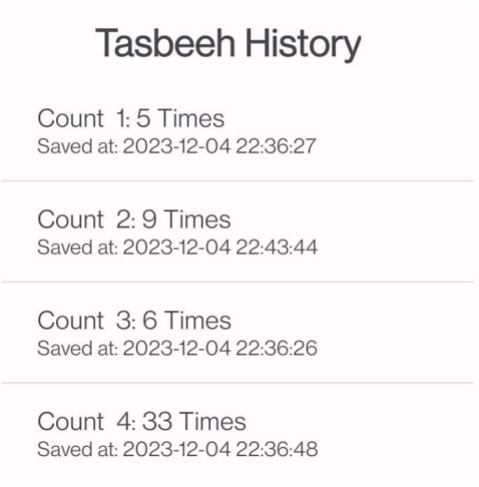
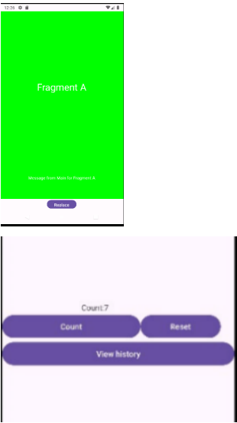
Conclusion:
In conclusion,we learn how to make SQLite database app of students data and tasbeeh database by using java and xml.

